Q 1. What are the default Bootstrap text settings?

Ans. Bootstrap 4 uses a default font-size of 16px, and its line-height is 1.5. The default font-family is "Helvetica Neue", Helvetica, Arial, sans-serif. In addition, all <p> elements have margin-top: 0 and margin-bottom: 1rem (16px by default)

Q 2. What do you know about the Bootstrap Grid System?

Ans. Bootstrap's grid system uses a series of containers, rows, and columns to layout and align content. It's built with flexbox and is fully responsive. Below is an example and an in-depth look at how the grid comes together

Q 3. What is the difference between Bootstrap 4 and Bootstrap 5.

|  |  |  |
| --- | --- | --- |
|  | Bootstrap 4 | Bootstrap 5 |
| **Grid System** | It has 5 tier (xs, sm, md, lg, xl). | It has 6 tier (xs, sm, md, lg, xl, xxl). |
| Color | It has limited colors. | Extra colors added with the looks, A card improved color palette. there are various shades available to choose. |
| Jquery | It has jquery and all related plugins. | Jquery is removed and switched to vanilla JS with some working plugins |
| Form elements | Radio buttons, checkboxes have different look in different OS and browsers. The form uses whatever default browsers provide. | The look of form elements will not change, on different OS or browser. The forms can be customized and form controls can be added, they would not depend on browser. |
| **Internet Explorer** | Bootstrap 4 supports both IE 10 and 11. | Bootstrap 5 doesn’t support IE 10 and 11. |

Q 4. What is a Button Group, and what is the class for a basic Button Group?

Ans. “Button Groups” in Bootstrap is a class of name “btn-group” which is used to create a series of buttons in groups (without spaces) vertically or horizontally. Syntax: This is the basic syntax of the button group class where each button has its own class of “btn”.

Q 5. How can you use Bootstrap to make thumbnails?

Ans.1. The first step is to include the Bootstrap and jQuery CDN into the head tag before having CSS's stylesheets.

2.We need to create a div tag in our HTML body. We will create three div sections for each image

3. We can add various col properties for making our page responsive, like col-sm-6 or col-md-3.

4.You need to create an anchor tag <a>, with a class name - .thumbnail wrapped around an image tag.

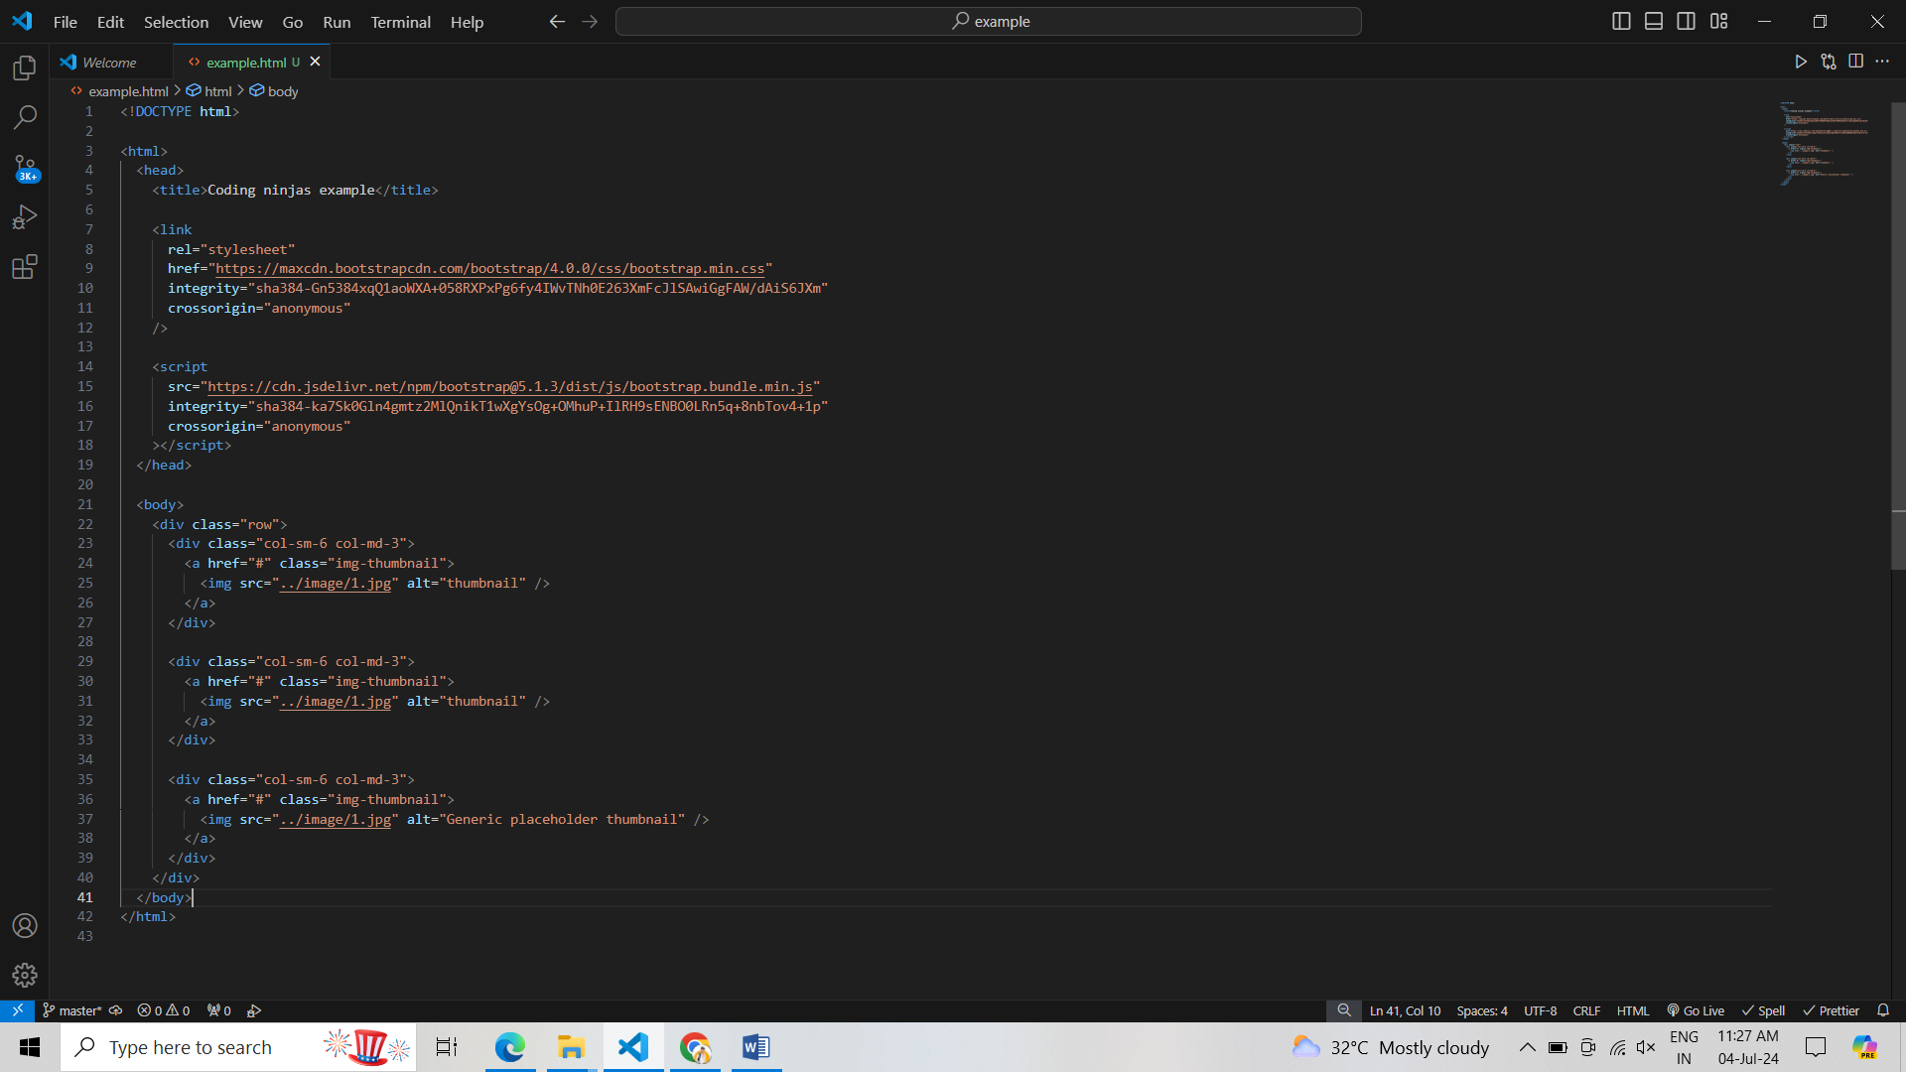**Example—**

Q 6. In Bootstrap 4, what is flexbox?

Ans. In Bootstrap 4, flex box is used to control the layout and alignment specification of Bootstrap 4 components. This box makes it easier to design flexible responsive layout structures without using float or positioning attributes.

Q 7.How can one create an alert in Bootstrap?

Ans. alert-secondary, . alert-light, and . alert-dark are been used to represent the alert message with different behavior. We will generate the dynamic alert message when the user clicks on the button